Project
Production of the axel for the Tesla

Problem statement:
The axel for the Tesla should be designed in such a way that it can be produced commercially with the industrial techniques. The shaft should bear the load and should be commercially also profitable.
Design and production methodology:
The following steps should be acquired in order to design and produce the shaft in the industries.

Given details:
Length of the shaft:22.680 inch
Diameter of the shaft:0.992 inch
Diameter of the groove:1.106
Diameter of the thread:1.083 inch
Length of the thread:1.419 inch
Length of grooves from end point:5.061 inch

Design of the shaft in the solid works:
Front view:
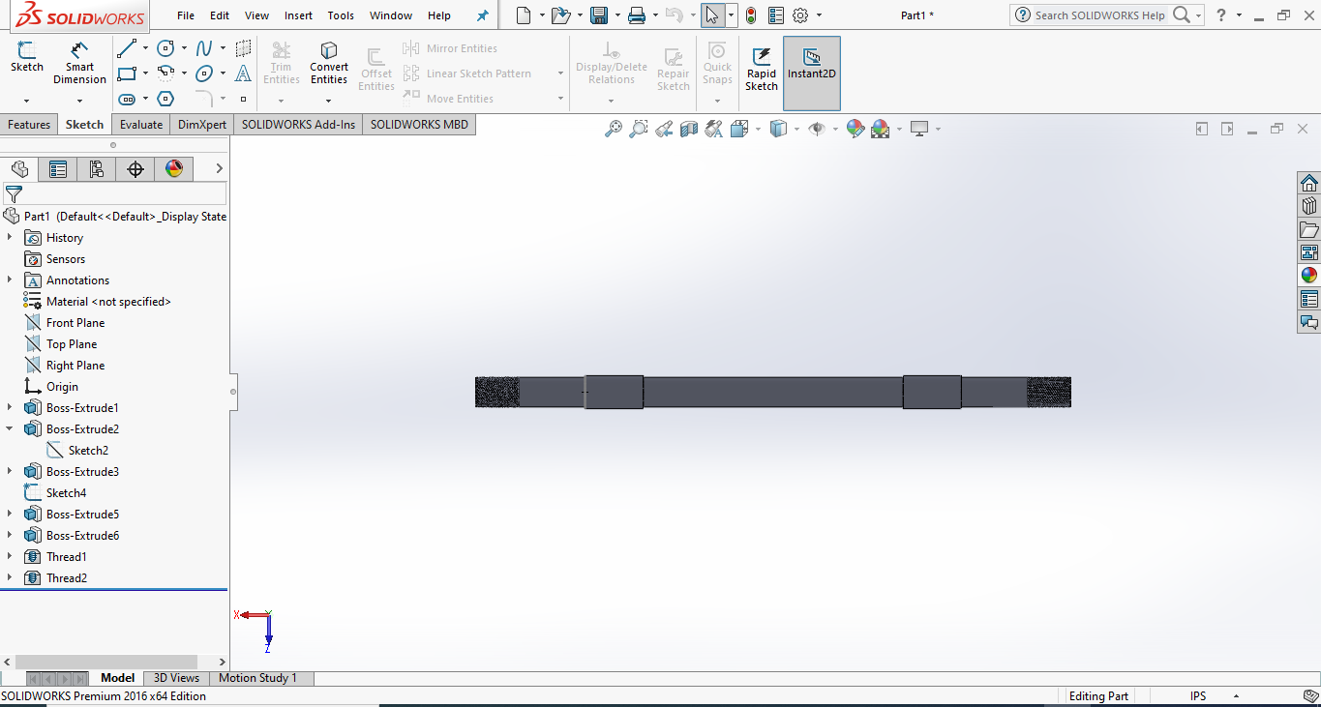
Axial view:

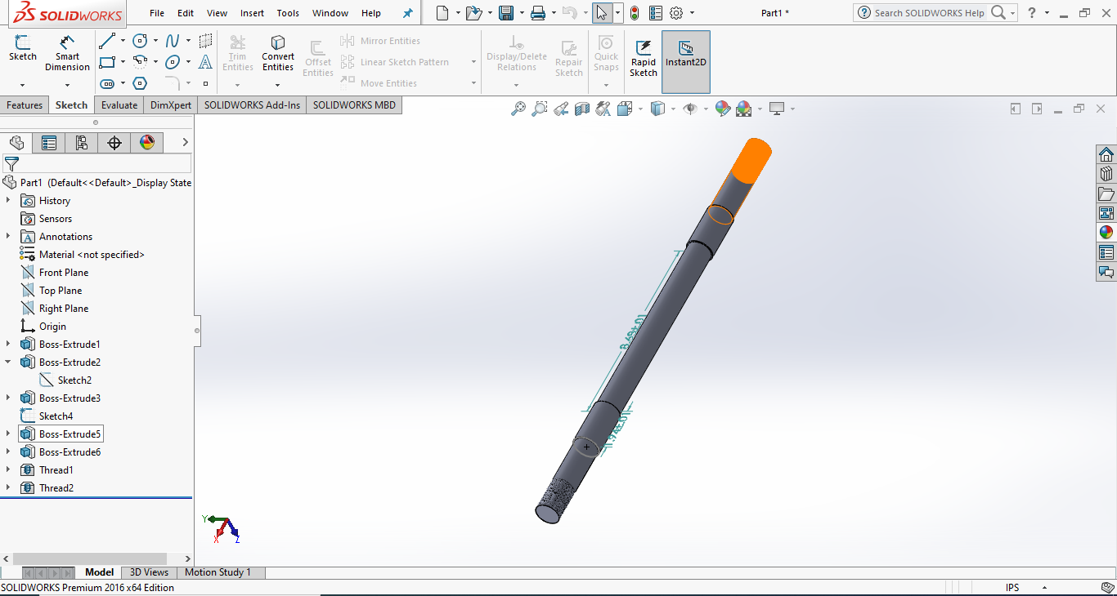
- Material selected:
The material selected for this shaft will be carbon steel.

- Testing of the material:
The material wil be tested in the Brinell hardness testing machine in the research lab and will be seen whether the material can bear the load.

- Selection of the road:
The rod of diameter 1.3 inches and length 23 inches will be selected.
- Facing of rod:

Facing is the process of removing metal from the end of a workpiece to produce a flat surface. Most often, the workpiece is cylindrical, but using a 4-jaw chuck you can face rectangular or odd-shaped work to form cubes and other non-cylindrical shapes.

When a lathe cutting tool removes metal it applies considerable tangential (i.e. lateral or sideways) force to the workpiece. To safely perform a facing operation the end of the workpiece must be positioned close to the jaws of the chuck. The workpiece should not extend more than 2-3 times its diameter from the chuck jaws unless a steady rest is used to support the free end.

Cutting Speeds
If you read many books on machining you will find a lot of information about the correct cutting speed for the movement of the cutting tool in relation to the workpiece. You must consider the rotational speed of the workpiece and the movement of the tool relative to the workpiece. Basically, the softer the metal the faster the cutting. Don't worry too much about determining the correct cutting speed: working with the 7x lathes for hobby purposes, you will quickly develop a feel for how fast you should go.

Until you get a feel for the proper speeds, start with relatively low speeds and work up to faster speeds. One of the great features of the 7x is that you can adjust the rotational speed without stopping to change belts or gears. Most cutting operations will be done at speeds of a few hundred RPM - with the speed control set below the 12 O'clock position and with the HI/LO gear in the LO range. Higher speeds, and particularly the HI range, are used for operations such as polishing, not cutting.

Preparing for the Facing Cut
The facing will be done in following steps.

- Insert in the chuck at both ends in the CNC automatic lathe.
- Cut the rod at both ends for 0.16 inch

- Centring of the rod:
Centring is a cutting operation with primarily double-edged tool (center drill) but also with single-edged tool (turning tool). It is used prior to other cutting operations, such as turning between centers, taper turning, drilling and grinding. In centring the rod will processed to do the further turning.

- Turning:
In the turning the extra diameter will be ended.It will be processed as follows.
- The first turning cycle of the lathe will be at 1.106 inch at both sides.
- The second turning cycle will be of 1.083 inches and the grooves will be excepted.
- The third turning cycle will be of 0.992 inches excepting the thread(1.419 inches at both sides) and grooves(1.94 inches at both sides) area.

- Threading:
The splines will be made on the center less machine of desired diameter by forcing and rolling the dice The diameter of the thread will be 1.083 inches and the angle will be 45 degrees. The length of the thread will be 1.419 inches at both sides.

- Hardness:
The hardness will be maintained on the induction machine.

- GM Code:

G00 G90 G17 G21
M03 S3000
(Contour 0)
T1 M06
X-4.676 Y-7.144
G01 Z-2. F150
X-4.787 Y-7.215 F450
X-4.829 Y-7.331
X-4.796 Y-7.474
X-4.693 Y-7.622
X-4.536 Y-7.754
X-4.348 Y-7.848
X-4.158 Y-7.891
X-3.995 Y-7.876
X-3.883 Y-7.806
X-3.841 Y-7.69
X-3.874 Y-7.547
X-3.977 Y-7.398
X-4.135 Y-7.267
X-4.323 Y-7.172
X-4.513 Y-7.129
X-4.676 Y-7.144
G00 Z5.
(Contour 1)
X-3.976 Y-7.88
G01 Z-2. F150
X-3.929 Y-7.859 F450
X-3.887 Y-7.827
X-3.856 Y-7.787
X-3.837 Y-7.74
X-3.83 Y-7.688
X-3.836 Y-7.631
X-3.854 Y-7.572
X-3.884 Y-7.51
X-3.925 Y-7.449
X-3.976 Y-7.39
X-4.035 Y-7.333
X-4.103 Y-7.281
X-4.176 Y-7.234
X-4.252 Y-7.194
X-4.331 Y-7.162
X-4.41 Y-7.139
X-4.488 Y-7.124
X-4.561 Y-7.119
X-4.629 Y-7.124
X-4.689 Y-7.138
X-4.741 Y-7.162

